Date: 07/01//2021

Subject: California Proposition 65 Compliance Statement

As part of our product stewardship and regulatory compliance efforts, we continue to monitor potential regulatory, safety, health and environmental impact of using your products. As such, we would like to inform you regarding the new requirements of the regulation concerning California Proposition 65.

California Proposition 65, officially known as the Safe Drinking Water and Toxic Enforcement Act of 1986, became law in November 1986. Proposition 65 requires businesses to provide warnings to Californians (and others doing business in the State of California) about significant exposures to chemicals that are known to cause cancer, birth defects or other reproductive harm. On August 31, 2016, the State of California Office of Environmental Health Hazard Assessment (OEHHA) adopted certain amendments to Article 6, Clear and Reasonable Warnings for California Proposition 65 which become effective on August 30, 2018. For more information on warnings, go to www.P65Warnines.ca.gov.

All products supplied by PASU does not contain the substances regulated by California Proposition 65 in concentrations resulting in exposures above the safe harbor levels determined by OEHHA. As such, these products are not required to have the California Proposition 65 warning labels.

Progressive Alloy Steels Unlimited, Inc. does not intentionally add any of the restricted substances it supplies.

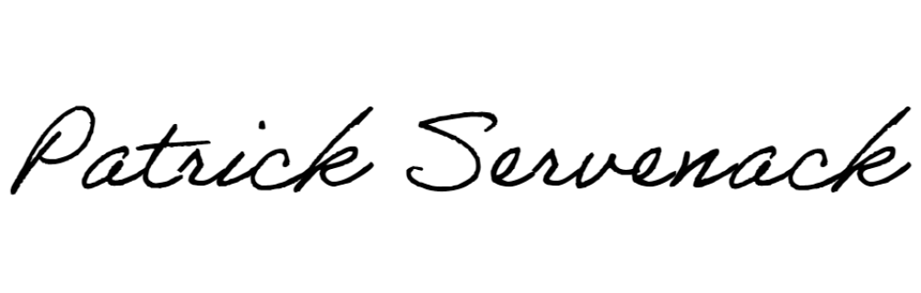
Thank You,

Patrick Servenack (pservenack@progressivealloy.com)
Quality Manager, Progressive Alloy Steels Unlimited, Inc.

