Date: 07/15/2022

Subject: REACh Compliance Statement

In June 2007, the European Union Regulation (EC) 1907/2006 concerning the Registration, Evaluation, Authorization and Restriction of Chemicals (REACh) entered into force. This Regulation establishes specific duties and obligations on companies in the European Union (EU) that manufacture or import substances on their own, in preparations, or in articles.

Under the structure of the REACh Regulation, the material PASU supplies are classified as “articles”, which do not contain “substances” intended for release. In accordance with the REACh Regulations, product classified as “articles” are not required to register their constituent “substances”, nor are they required to pre-register.

Article 3 of REACh defines an “article” as: “An object which during production is given a special shape, surface or design which determines its function to a greater degree than does its chemical composition”.

PASU will consistently monitor the substance of very high concern (SVHCs), as defined by REACh. This will be an ongoing process since the complete list of SVHCs will be released in stages. Our customers are encouraged to visit the following site to get the most up to date information on the current list of SVHC under REACh. http://echa.europa.eu/web/guest/candidate-list-table.

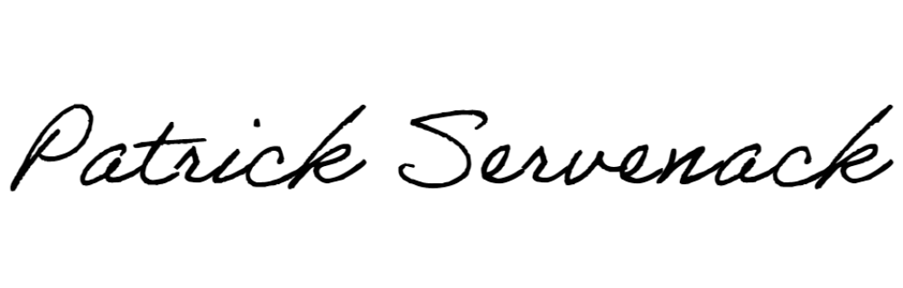
Thank You,

Patrick Servenack (pservenack@progressivealloy.com)
Quality Manager, Progressive Alloy Steels Unlimited, Inc.

